1: Options for each answer is :
Teamworker
Plant
Monitor Evaluator
Complete finisher

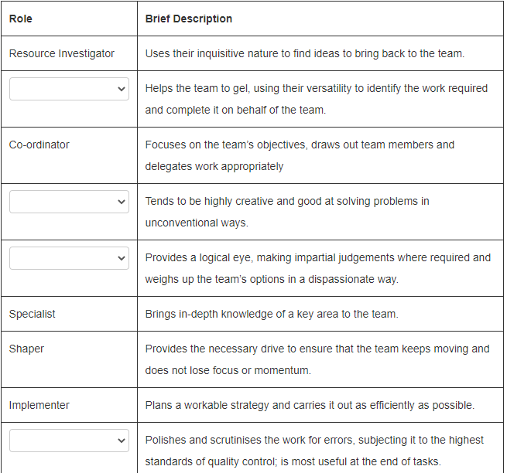

Teamworker
Plant
Monitor Evaluator
Complete finisher

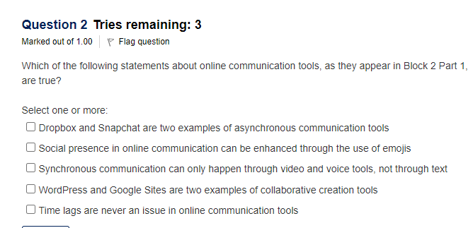
1, 4

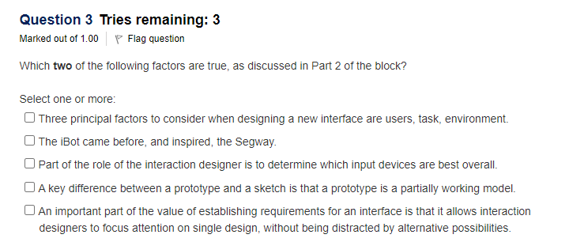
1, 4, 5
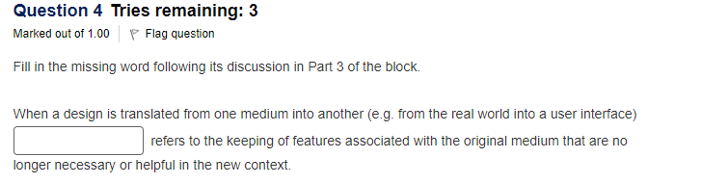
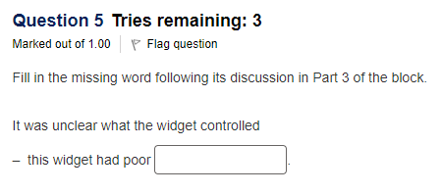

6: Answer Options
Social effects
Group effects
Standards
Effectiveness
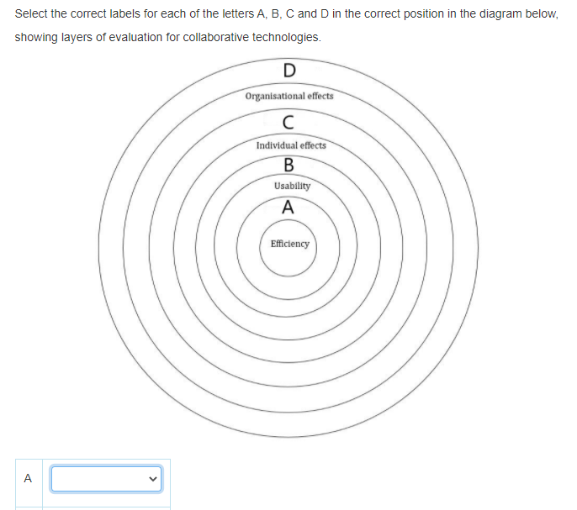
A: Standards
B: Effectiveness
C: Group Effects
D: Social Effects

1 & 2

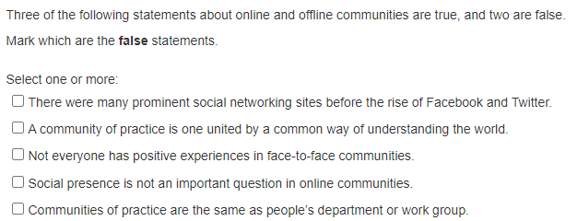
1 & 4

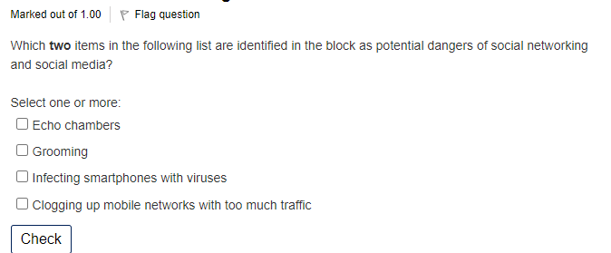
3 & 4

